Lesson 1 Homework | LT 1.1 and 1.2 | 1, 3-6, 8-12, 16-20, 25, 26

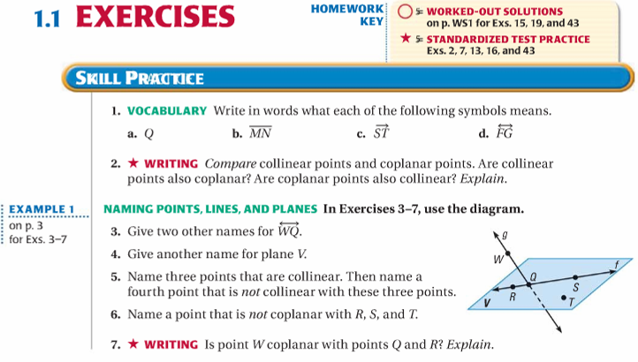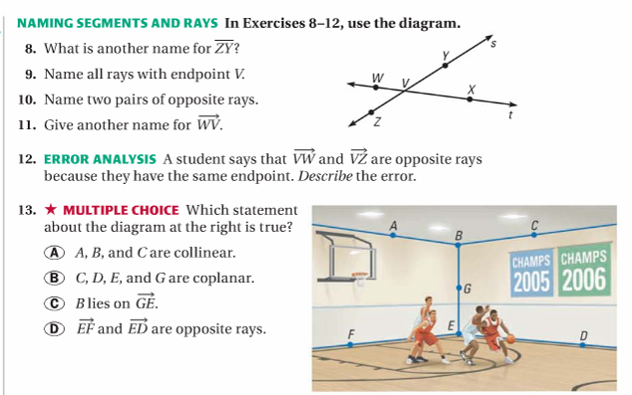

Lesson 1 Homework | LT 1.1 and 1.2 | 1, 3-6, 8-12, 16-20, 25, 26

